MVCH System

Zedd Whitaker, Sarah Powell, Dillon Regimbal, Calvin Lapp

# Table of Contents

**Table of Contents** **1**

**Reports & Justifications** **4**

Room Utilization Report 4

Justification 4

Daily Revenue Report 5

Justification 5

Patient Bill 6

Justification 6

Revenue Analysis 7

Justification 7

Physician Profit & Loss 8

Justification 8

Profit Total Graphs 9

Justification 10

**Reference Documents** **11**

Home 11

Login 11

Help 12

Physician 12

Login Landing 12

Administrative Staff 14

Login Landing 14

Search Patients - Loaded by default is an uncollapsed Search Patients function. This list can be expanded and collapsed by clicking the grey arrow on the right of the Search Patients panel. 14

Patient Search Entry Area - Enter a name or a part of a name to search for their patient record. 14

Search Button - After entering a name in the patient search entry area, click the Search button to perform the search. 14

Patient Information Form 15

Admit Patient Form 15

Update Patient Form 16

Generate Bill Form 16

Clerical Staff 17

Login Landing - Item Search 17

Item Information Form 17

Add Item to Cost Centre Form 18

Cost Centre Item View 18

Patient 18

Login Landing - Personal Medical Records 18

Login Landing - Current Account 19

Login Landing - Account History 19

**Procedural Documents** **20**

Physician 20

How to Login 20

How to Logout 20

Password Reset 20

How to View your Patient List 21

How to View your Physician Alerts 21

How to View your Personal Schedule 21

Administrative Staff 21

How to Login 21

How to Logout 22

Password Reset 22

Clerical Staff 22

How to Login 22

How to Logout 23

Password Reset 23

Patient 23

How to Login 23

How to Logout 24

Password Reset 24

**Tutorials** **25**

All Staff 25

How to View Staff Alerts 25

How To View Personal Schedule 25

How To Search Help Topics 25

How To Login 25

Physicians 25

How To View Active Patients 25

Admission Staff 25

How To Add A Patient: 25

How To Update A Patient 25

How To Admit A Patient 25

How To Print A Patient Bill 26

Clerical Staff 26

How To Add An Item 26

Patients 26

How To View Current Account Balance 26

# Reports & Justifications

## Room Utilization Report

### Justification

This report allows the administration and other relevant staff to quickly see data on the occupational status of the hospital.

The layout is simple, everything is clearly labelled, and there is no unnecessary information. The date is at the top so that historically generated reports can be identified by the date it was created. The detailed lines are ordered by the room number, and the total number of vacant beds for each room type is listed at the bottom of the report.

## Daily Revenue Report

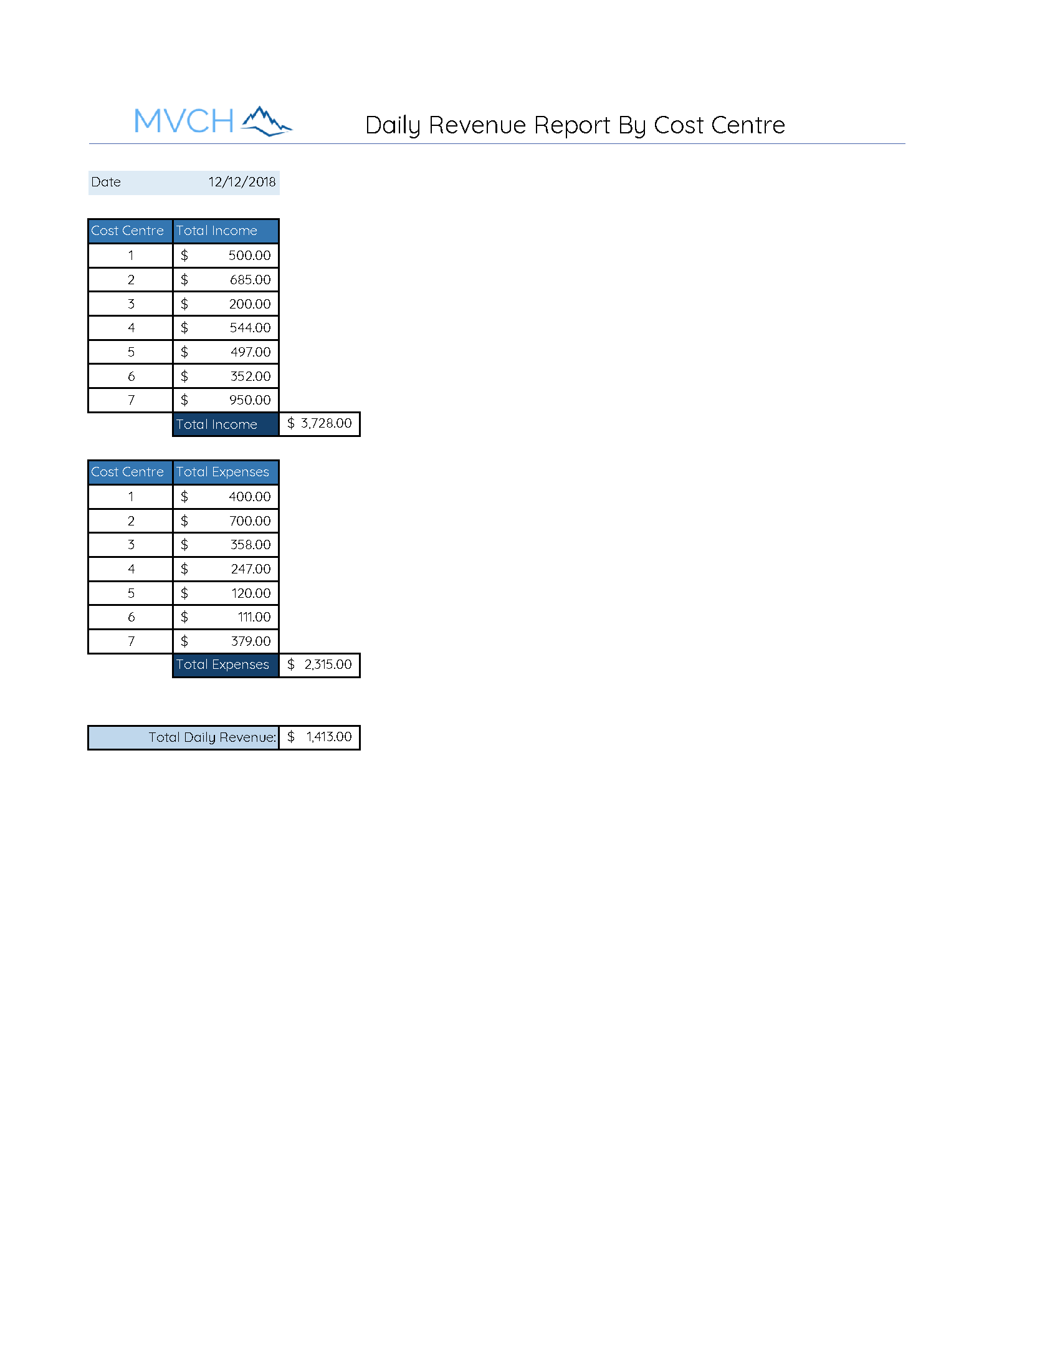

### Justification

This report allows the administration to quickly see not only aggregate daily revenue data, both increases and decreases, but the overall revenue total, and the breakdown by cost centre if they wish to look closer.

The layout is simple, using colour to draw the attention to totals, and offset cells to highlight totals. Everything is clearly labelled, and there is no extraneous information. The date is a required field at the top so that historically generated reports can be identified by the date it was created.

No further breakdown is required for this report because it is intended to be a quick daily overview. Other reports would be required for further understanding of how daily revenue was generated by cost centre, physician, patient type, etc., but this is not the purpose of the quick overview of daily revenue generated here.

## Patient Bill

## 

### Justification

This report allows the patient to see everything that was charged to them during their stay at the hospital in a simple yet complete chart displaying all necessary information.

Colors in the report are used to bring attention to main details and split sections to make it easier for viewing. The subtotal record is colored blue to bring emphasis to that section while simultaneously splitting the previous and next records apart. At the end a darker and new color is introduced to signal the end of the report. This color is different from all others and darkest to show a difference in the report, bring attention to it, and signal that it is the end.

The report is displayed in ascending order of the cost centre values of each record. Multiple records before each subtotal are grouped based off the last shown cost centre. At the end, all subtotals are added and displayed as a grand total due.

## Revenue Analysis

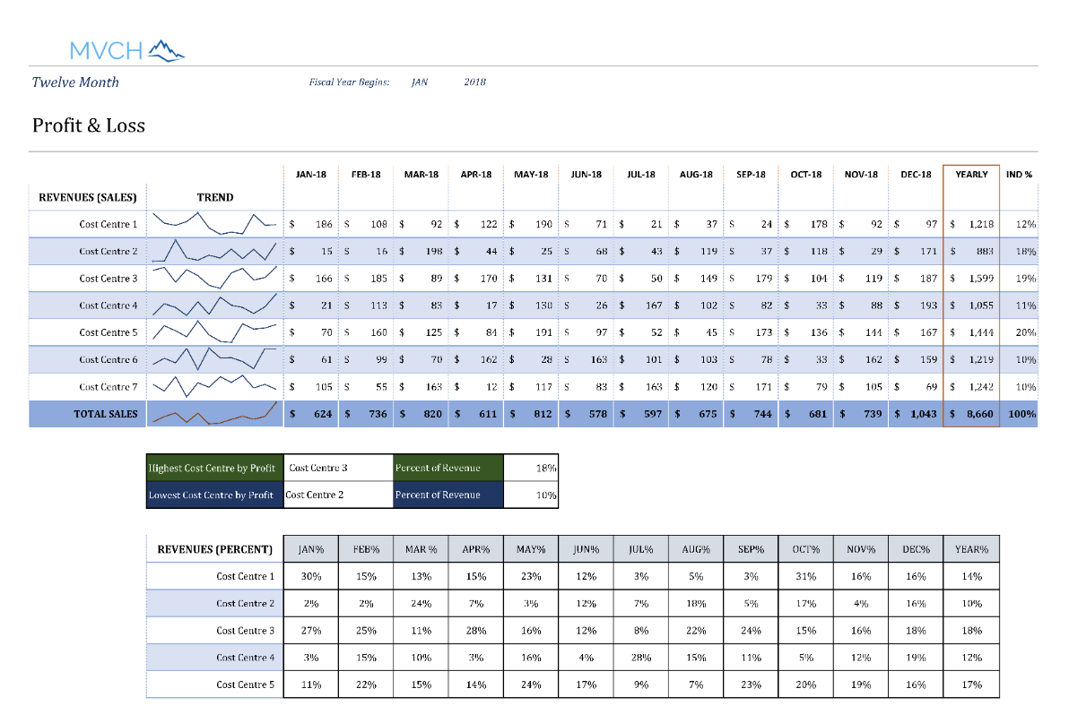

### Justification

This revenue analysis report offers both aggregated data and interpreted data. The totals by cost centre are broken down for the year, and totalled by month and by cost centre. The data is then reinterpreted as percentages. The top earning cost centre and the lowest earning cost centre for the year are also drawn out, and their relative percentages of total income is given.

There is a lot of data in this one report, so it is broken down into two larger graphs with the smaller, top and bottom earners break it it up a bit. Even though there is a lot of data here, the different forms of aggregation (line totals by number, by line graph, and by percentage) let the reader understand the data from different angles, combating bias that may creep into a single representation.

Clear labels and use of colour were essential to making this report easy to scan, read, and understand.

## Physician Profit & Loss

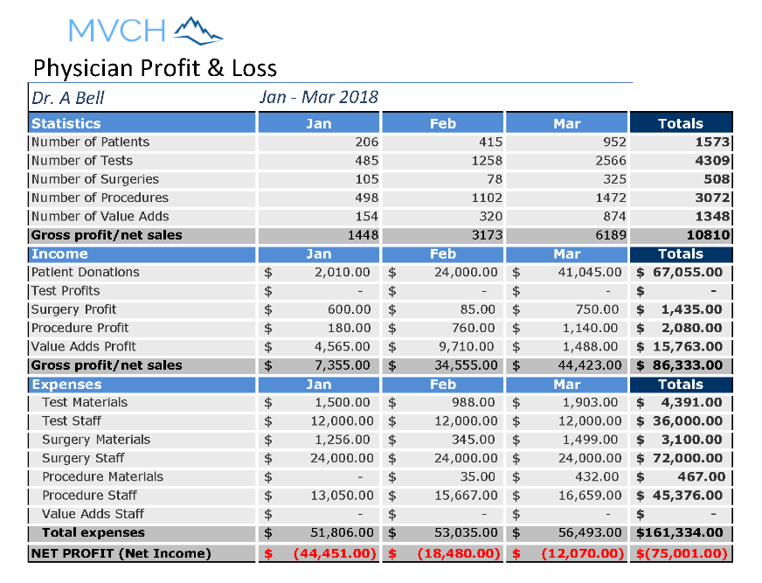

### Justification

This report allows the administrators to view a physician's contributions to the hospital in two ways: first, how they use facilities as demonstrated by the aggregated totals of patients, tests, surgeries, procedures, and value adds purchased by the patient.

This report acknowledges that for the hospital to continue, the cost versus revenue generation of a doctor is a factor in the health of the hospital. This is for an individual doctor but only does a general overview. If the numbers seemed unexplainable at a glance, further, more in-depth reports for doctors could be drawn up, looking at what sorts of test, procedures, and surgeries they were performing for what types of patients, as well as outcomes of these procedures. This report allows a quick overview so they can determine who requires more attention, or where the hospital is putting it’s financial resources. These reports could also be useful when soliciting target donations; they can demonstrate that valuable services are such an expense so please give in this area.

Again, the layout is clean, using colour to draw the eye to titles and totals. Negative totals are in red. A consistent accounting format for currency is used in this report. It doesn’t cram too much data in, but is a good start to indicate where to dive a bit deeper into the data.

## Profit Total Graphs

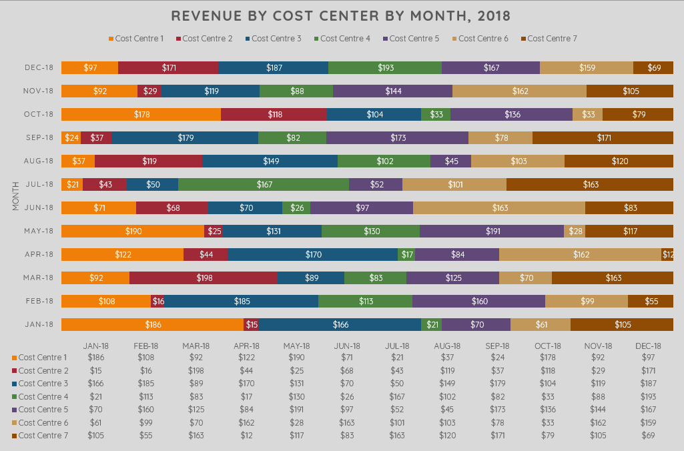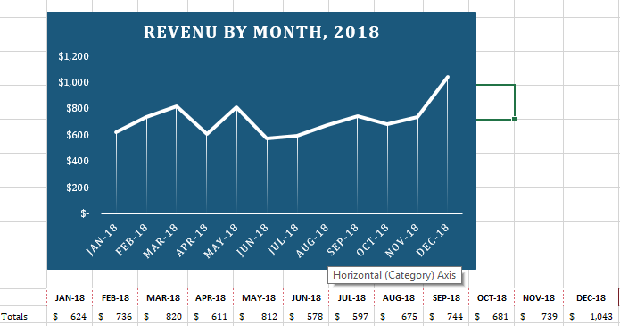

### Justification

At first, it may seem that these repeat information that is retrievable from the in-depth profit analysis, but we felt these were important graphs to add to the reports generated because they allow the data to be greatly simplified. By presenting less data, especially in the second graph, it gives a very quick, top-down view of the income of the hospital. These graphs can be useful in getting the briefest of snapshots of the hospitals financial health. Overtime, simple graphs like these can be compared to demonstrate the revenue standing of the hospital and highlight any very good or very poor months or years. As well, these types of easily-understood graphs are very useful when soliciting donations, to demonstrate need, or to show steady, financial management.

Colour is most important in the more detailed graph, because it allows us to represent the different cost centres quickly. The different bars compare the same period over time (month by month) and the fluctuating portion of revenue from each cost centre. The legend is easy to understand.

The second graph uses a monochromatic scheme in keeping with it’s simple data representation of overall revenue by month during the year. The scale on the axis is clean and increases from zero through a consistent step.

# 

# 

# Reference Documents

## Home

Navigation Bar - The navigation bar on the home page is the same for all users. It has navigation links to the Home page, the About page, the Help page, and the Login page.

Home (Navigation Bar) - Click the Home link in the navigation bar to load the Home page.

About (Navigation Bar) - Click the About link in the navigation bar to load the About page.

Help (Navigation Bar) - Click the Help link in the navigation bar to load the Help page.

Login (Navigation Bar) - Click the Login link in the navigation bar to load the Login page.

About Us (icon) - Click on the About Us icon below the top graphic to load the About page.

Login (icon) - Click on the Login icon below the top graphic to load the Login page.

Contact (icon) - Click on the Contact icon below the top graphic to navigate within the page down to the contact information at the bottom of the page.

## Login

Navigation Bar - The navigation bar on the home page is the same for all users. It has navigation links to the Home page, the About page, the Help page, and the Login page.

Home (Navigation Bar) - Click the Home link in the navigation bar to load the Home page.

About (Navigation Bar) - Click the About link in the navigation bar to load the About page.

Help (Navigation Bar) - Click the Help link in the navigation bar to load the Help page.

Email - Enter your system login email (required).

Password - Enter your system password (required).

login - After you have entered both your email and password, click the login button to access the system.

Sign Up (hyperlink text) - Click the Sign Up link to register as a new user of the system.

## Help

Navigation Bar - The navigation bar on the home page is the same for all users. It has navigation links to the Home page, the About page, the Help page, and the Login page.

Home (Navigation Bar) - Click the Home link in the navigation bar to load the Home page.

About (Navigation Bar) - Click the About link in the navigation bar to load the About page.

Help (Navigation Bar) - Click the Help link in the navigation bar to load the Help page.

Login (Navigation Bar) - Click the Login link in the navigation bar to load the Login page.

Search Bar - Enter a keyword or topic title that you want to search up in the help pages.

Search Button - Click the Search button after you have entered a keyword or topic that you want to search up in the help pages.

## Physician

### Login Landing

Navigation Bar - The navigation bar has navigation links to the Home page, the About page, the Help page, and the Logout function.

Home (Navigation Bar) - Click the Home link in the navigation bar to load the Home page.

About (Navigation Bar) - Click the About link in the navigation bar to load the About page.

Help (Navigation Bar) - Click the Help link in the navigation bar to load the Help page.

Logout (Navigation Bar) - Click the Logout link in the navigation bar to logout and load the Home page.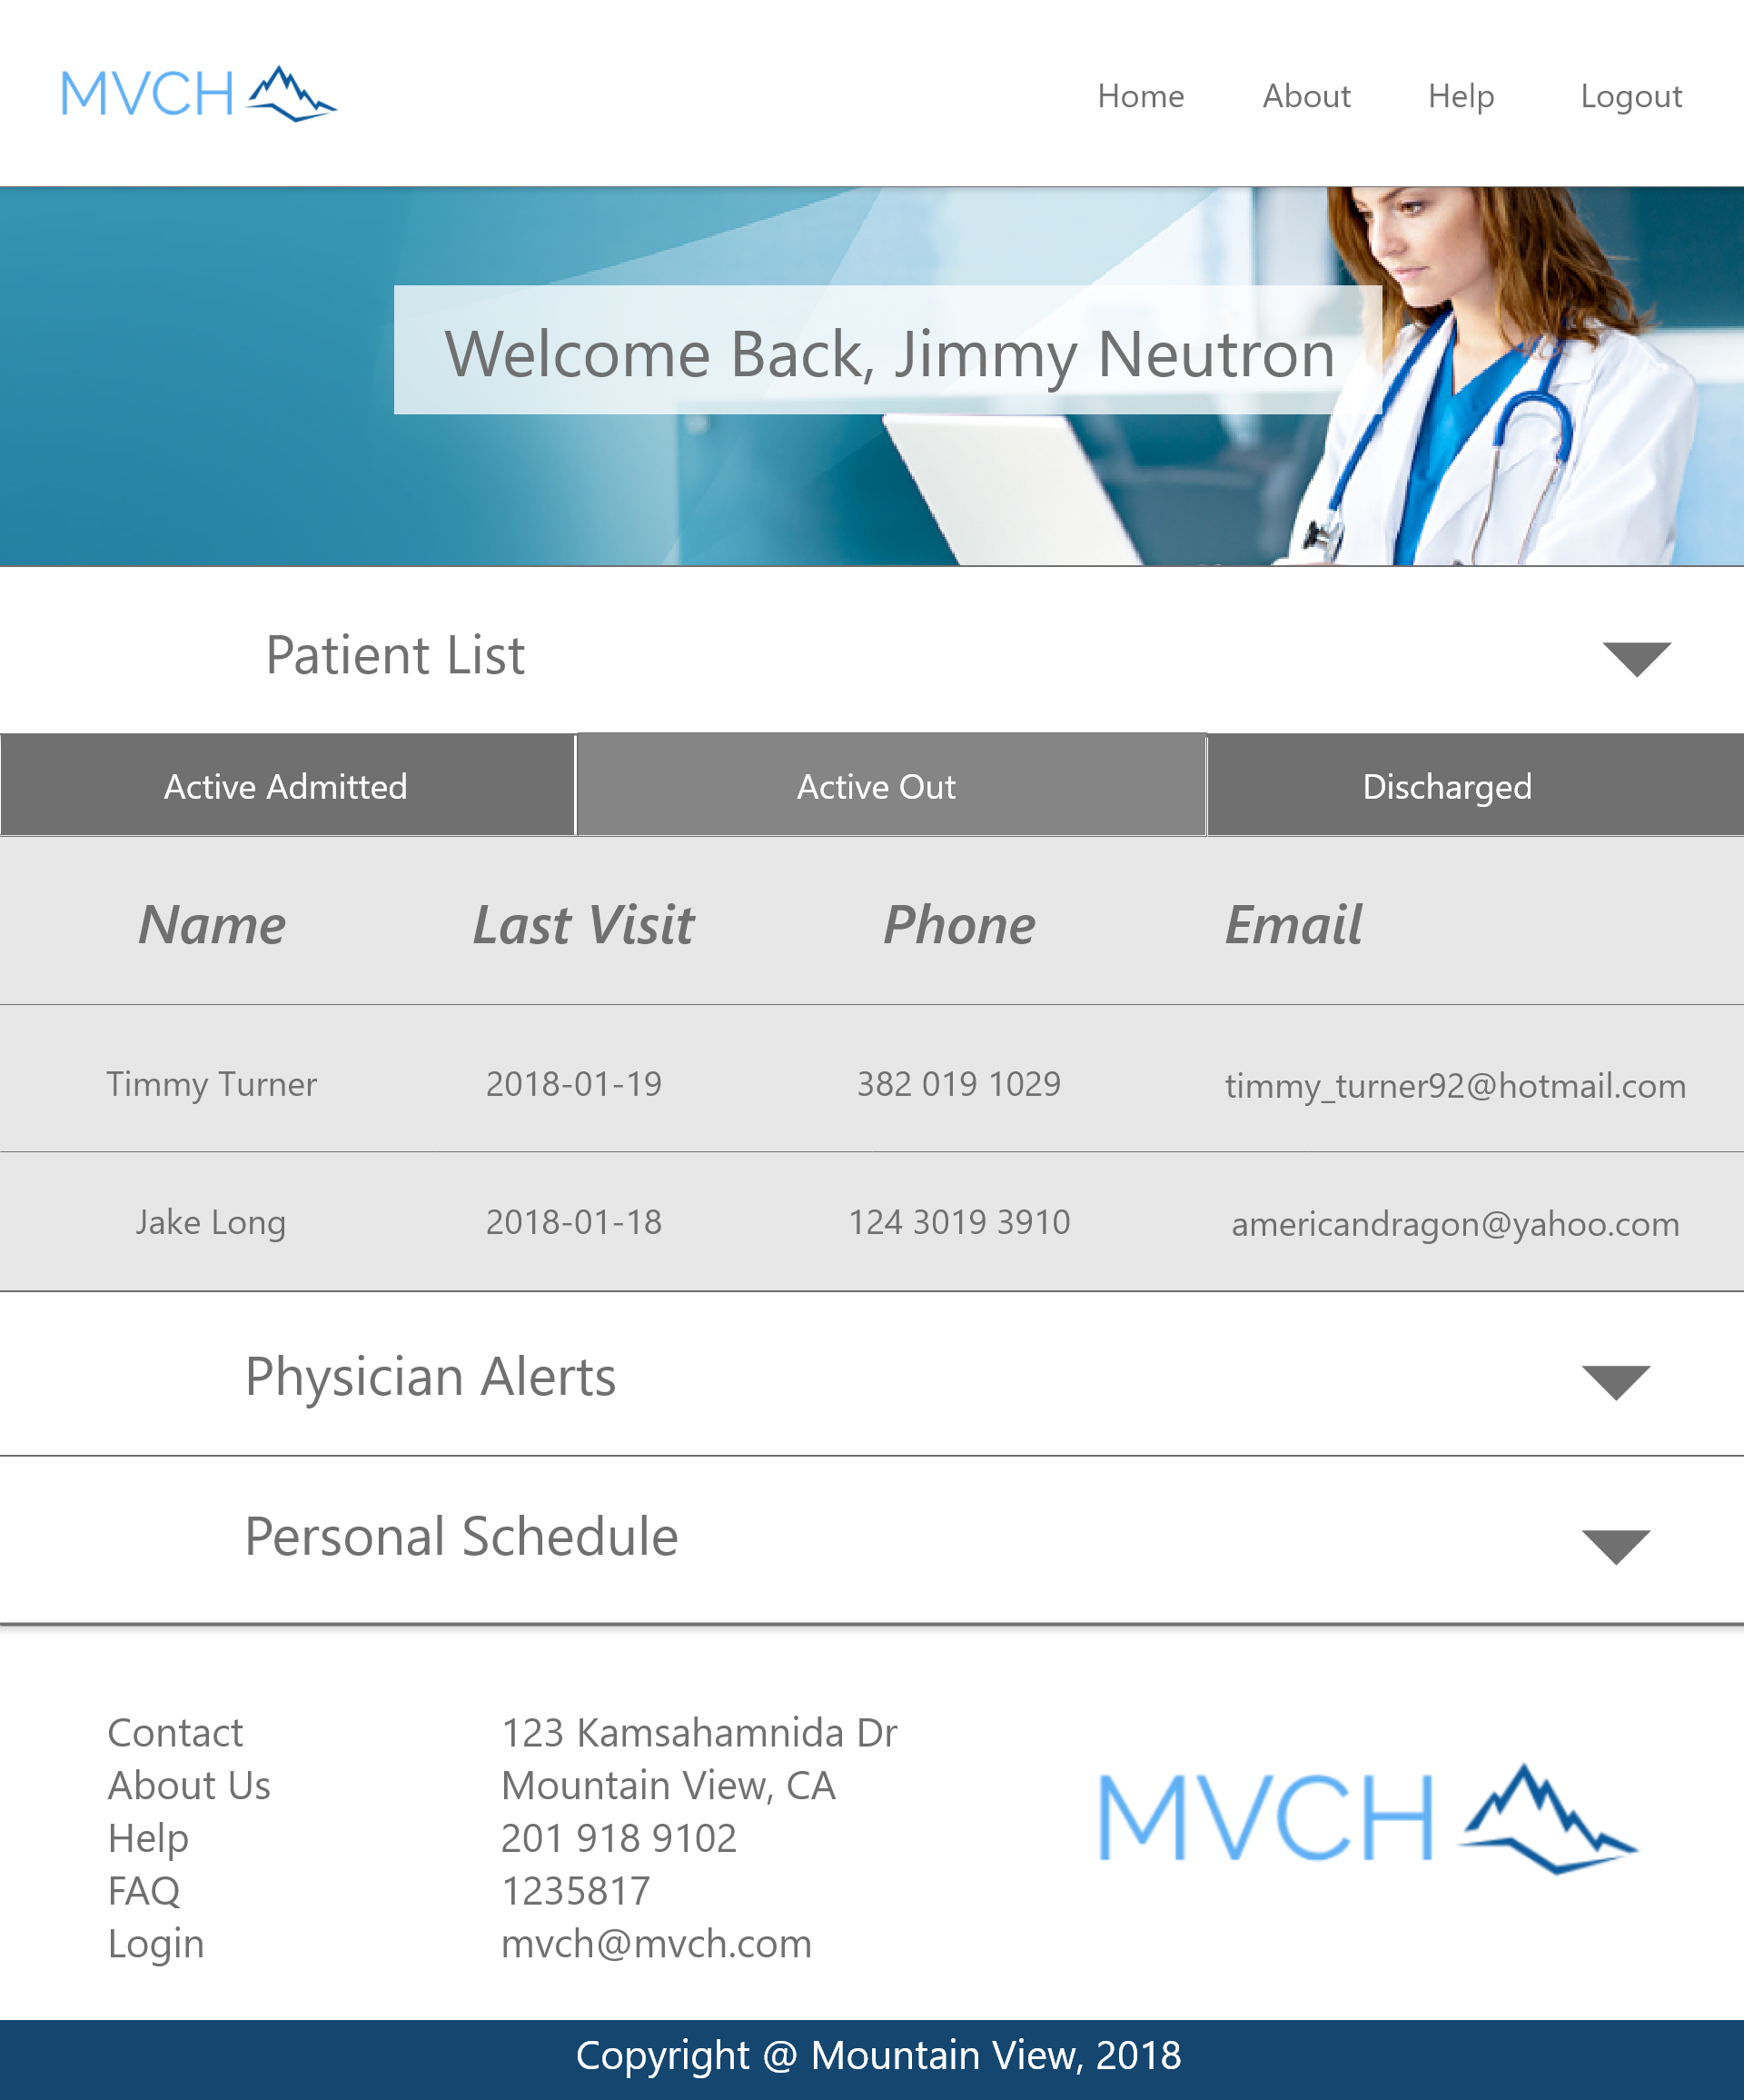

Patient List - Loaded by default is an uncollapsed patient list. This list can be expanded and collapsed by clicking the grey arrow on the right of the Patient List panel. You can scroll through the patient list, which displays the name, last visit, phone number, and email of your active patient list.

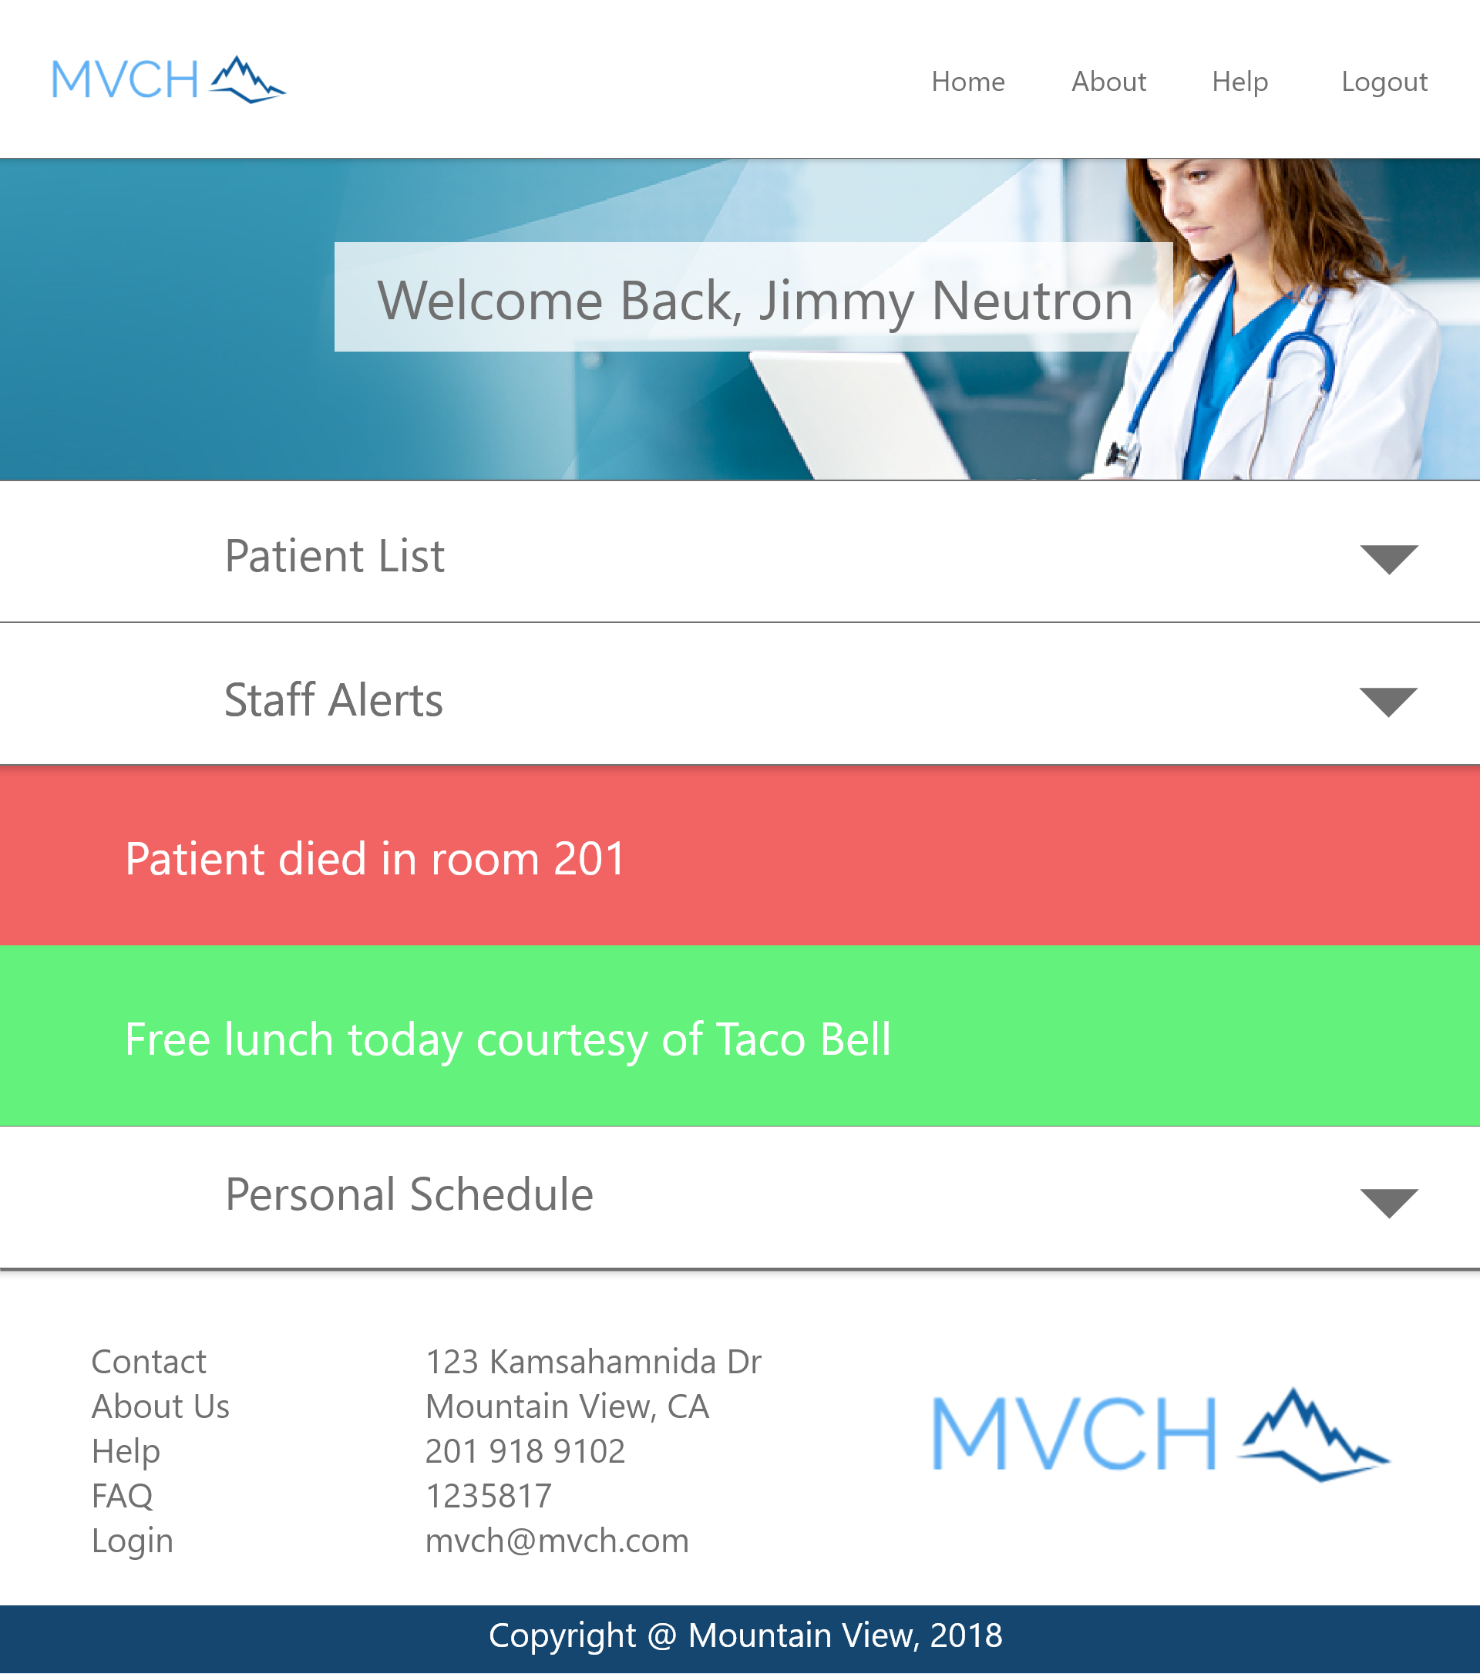

Physician Alerts - Expand or collapse the physician alerts area of the Physician Login Landing page by clicking the grey arrow to the right of the Staff Alerts panel. You can scroll through alerts. Alerts will only appear if activated by Administration.

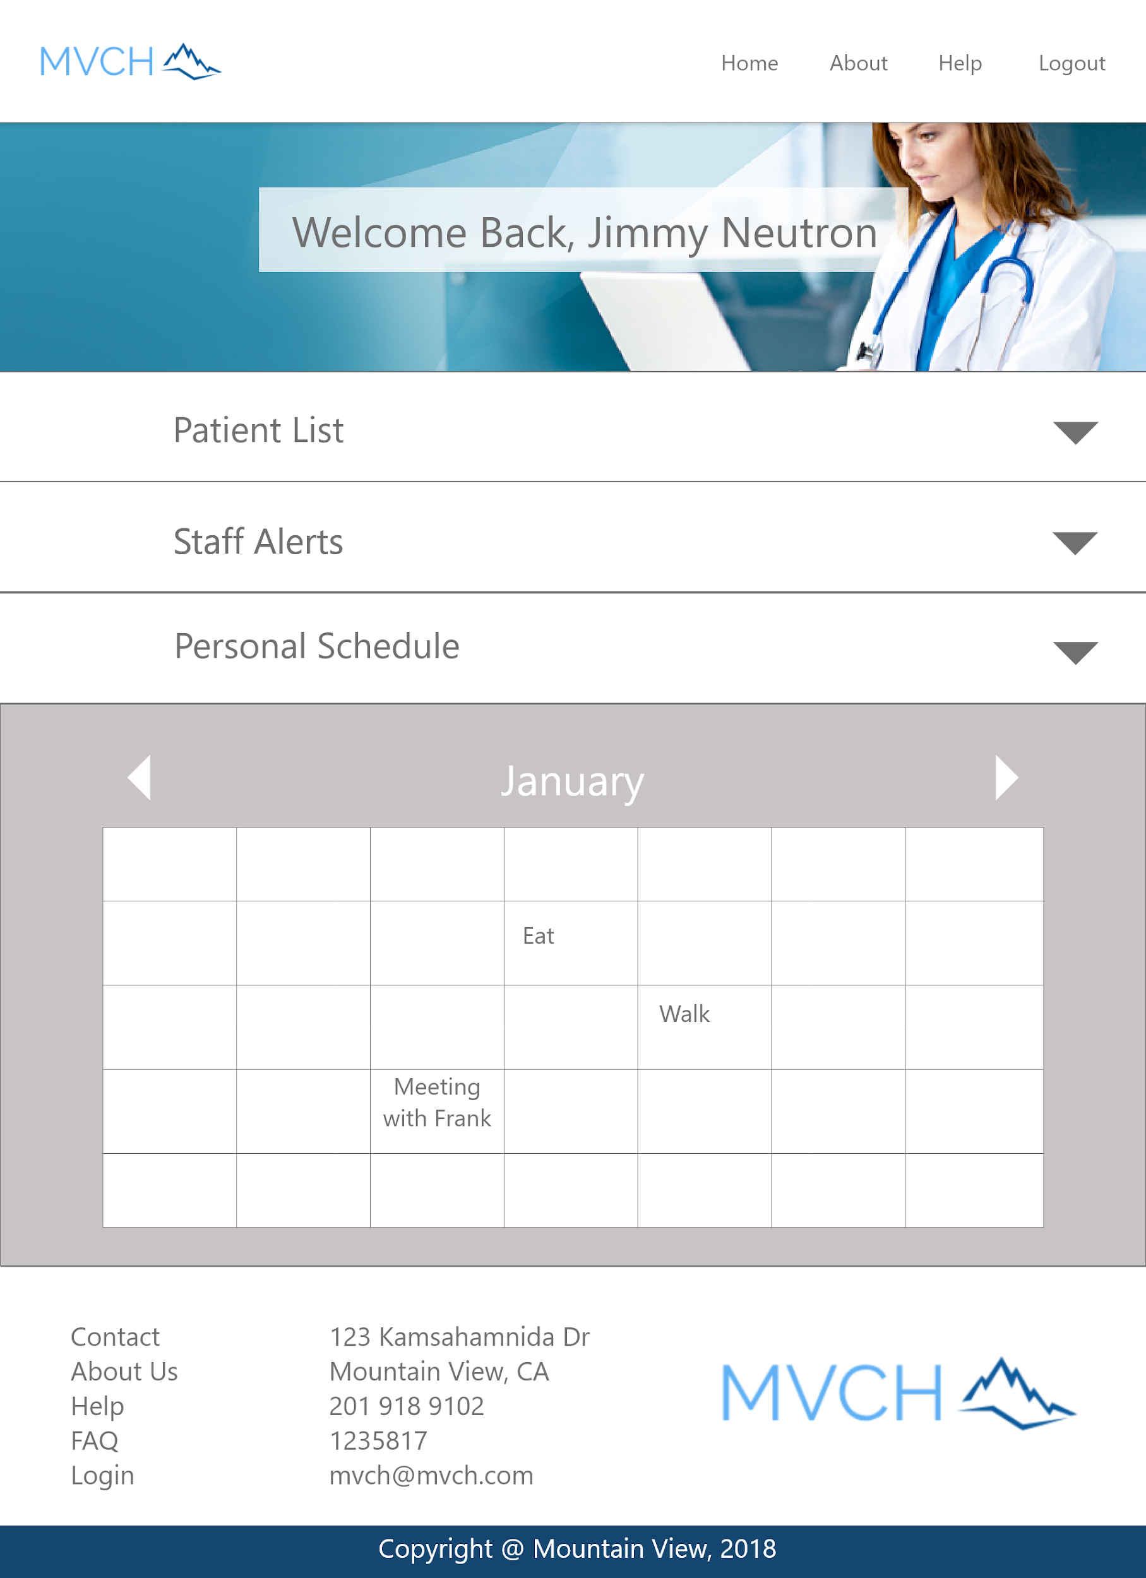

Personal Schedule - Expand or collapse the personal schedule area of the Physician Login Landing page by clicking the grey arrow to the right of the Personal Schedule panel. Your personal schedule will be displayed when expanded.

## 

## 

## 

## Administrative Staff

### Login Landing

Navigation Bar - The navigation bar has navigation links to the Home page, the About page, the Help page, and the Logout function.

### Search Patients - Loaded by default is an uncollapsed Search Patients function. This list can be expanded and collapsed by clicking the grey arrow on the right of the Search Patients panel.

### Patient Search Entry Area - Enter a name or a part of a name to search for their patient record.

### Search Button - After entering a name in the patient search entry area, click the Search button to perform the search.

Add a Patient Button - Click the Add a Patient button to create a new patient record.

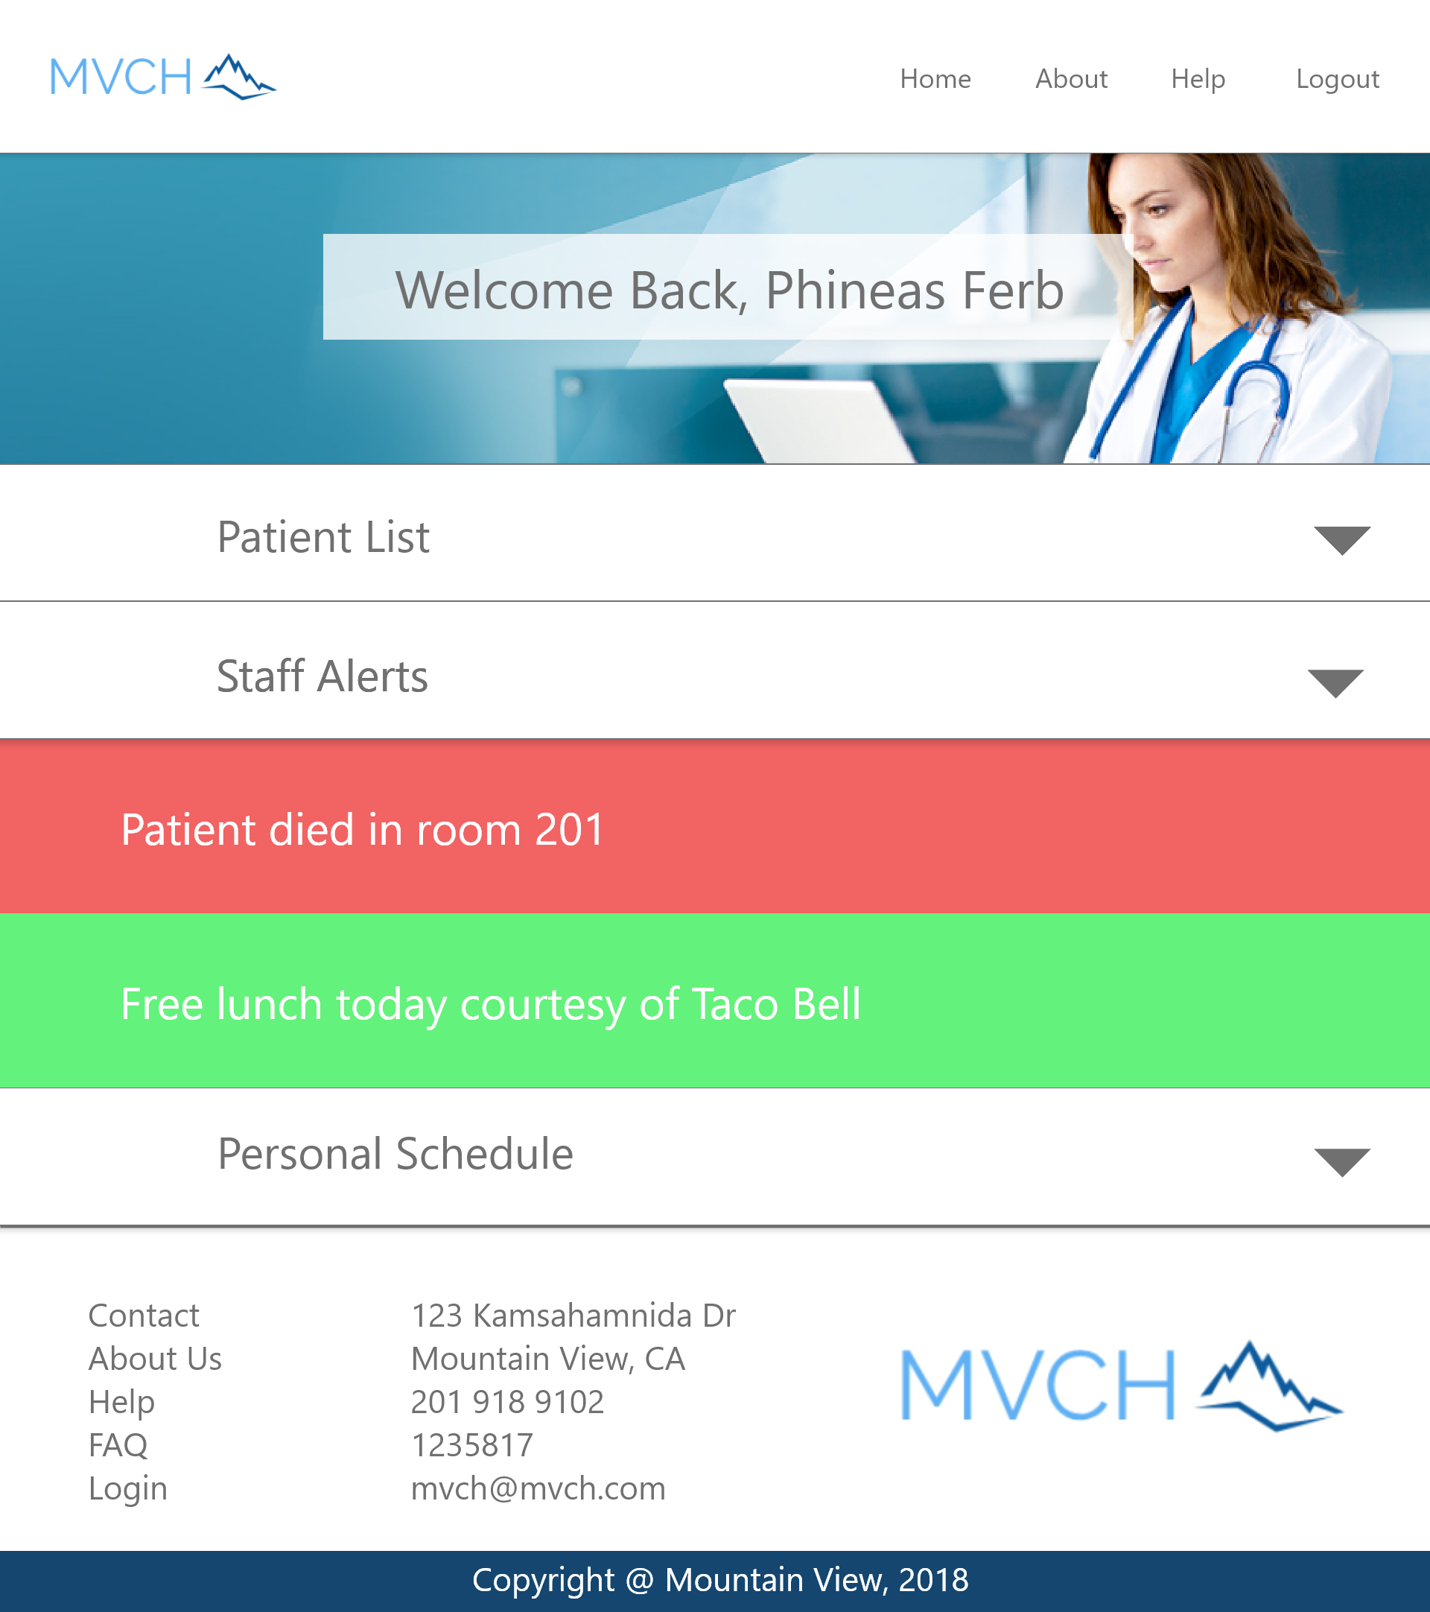

Staff Alerts - Expand or collapse the staff alerts area of the Administrative Staff Login Landing page by clicking the grey arrow to the right of the Staff Alerts panel. You can scroll through alerts. Alerts will only appear if activated by Administration.

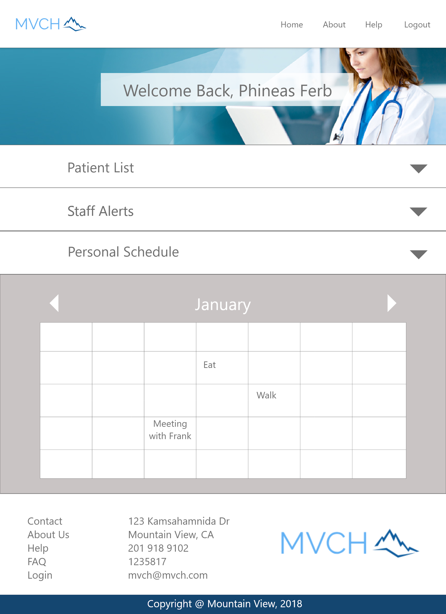

Personal Schedule - Expand or collapse the personal schedule area of the Administrative Staff Login Landing page by clicking the grey arrow to the right of the Personal Schedule panel. Your personal schedule will be displayed when expanded.

### Patient Information Form

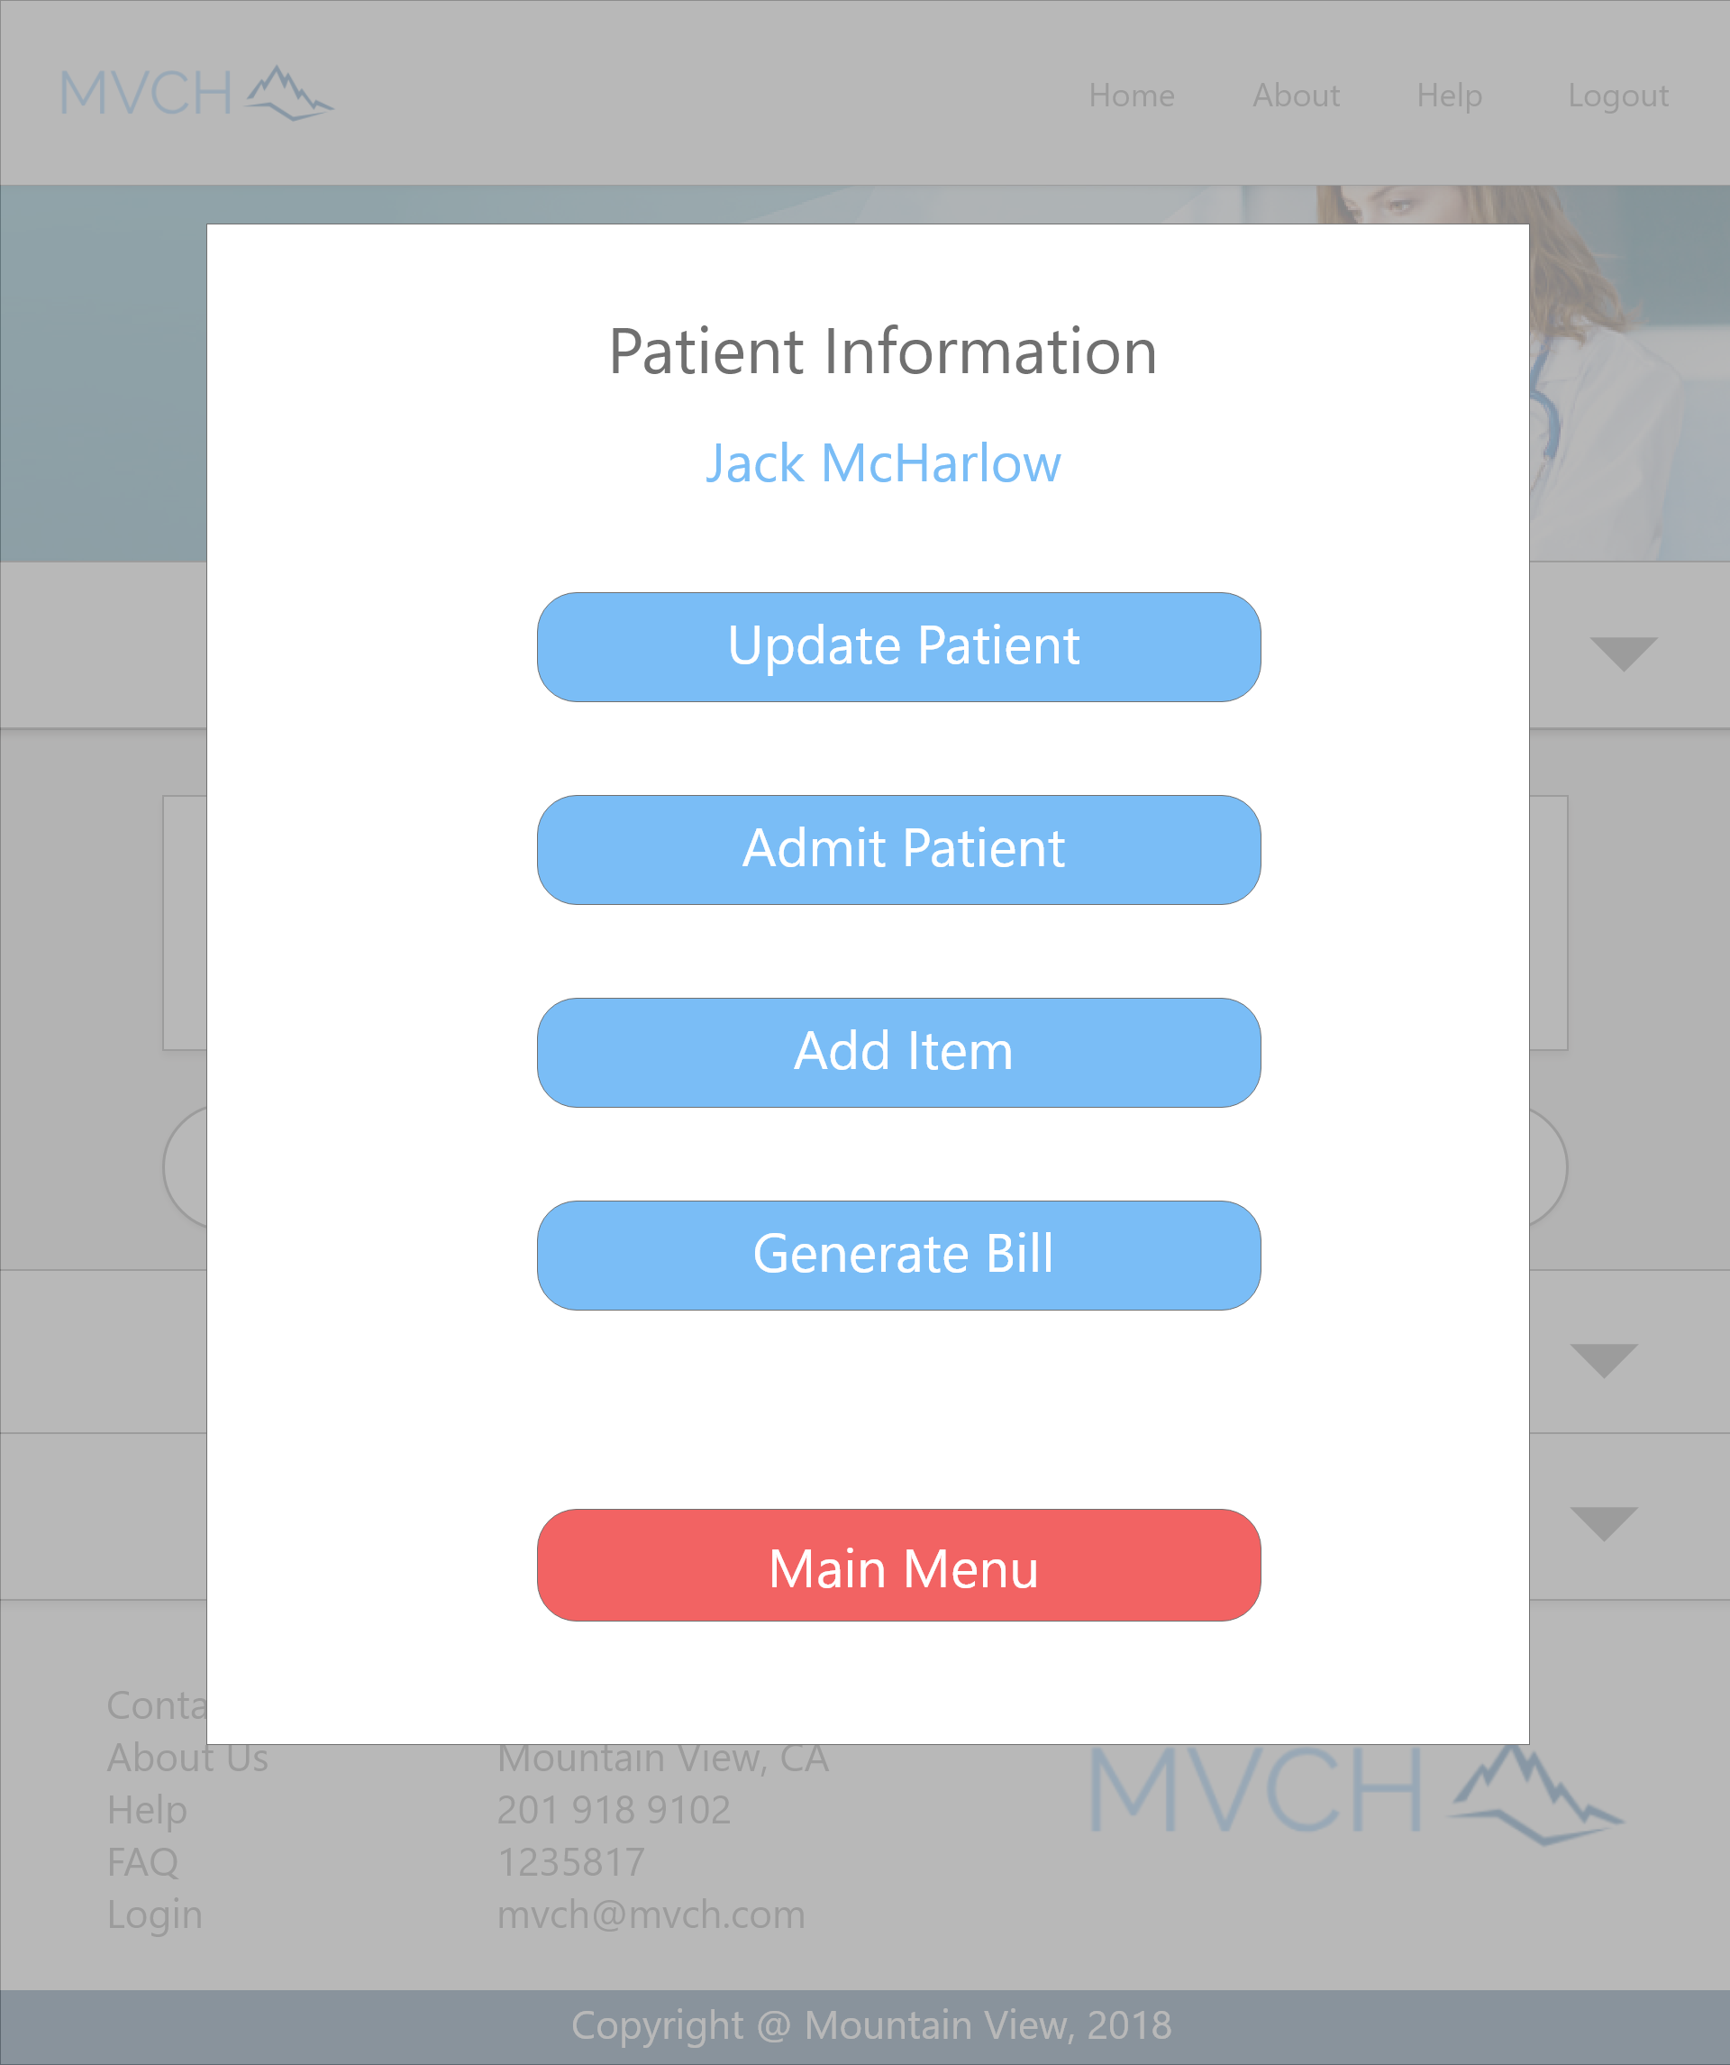

This form displays information about the currently selected patient.

Update Patient Button - Click the Update Patient button to access the update patient information form.

Admit Patient - Click the Admit Patient button to access the admit patient form.

Add Item - Click the Add Item button to access the Add Item form.

Generate Bill - Click the Generate Bill button to access the Generate Bill form.

Main Menu - Click the Main Menu button to return to the Administrative Staff Login Landing page.

### Admit Patient Form

This form allows you to admit a currently selected patient by assigning them a room.

Navigation Bar - The navigation bar has navigation links to the Home page, the About page, the Help page, and the Logout function.

Room Number Entry Area - Add the room number to which the patient will be admitted.

Admit Patient Button - Click the Admit Patient button after entering the patient’s designated room number to admit the patient.

Main Menu - Click the Main Menu button to return to the Administrative Staff Login Landing page.

### Update Patient Form

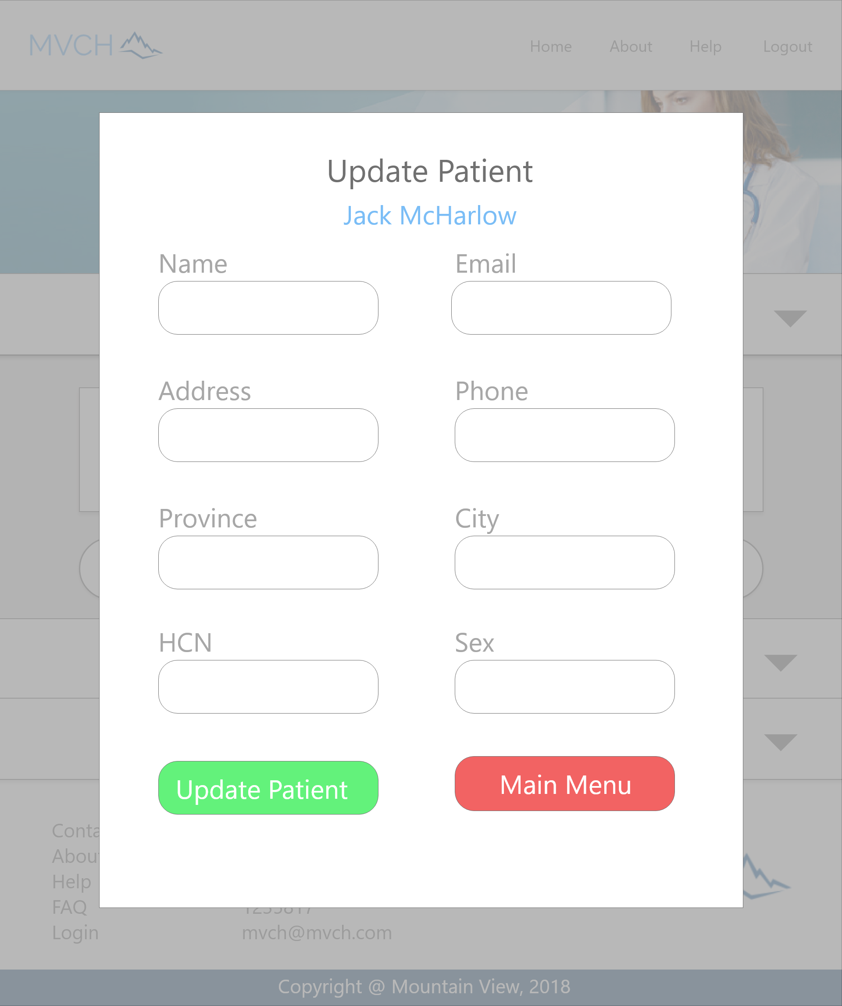

This form allows you to add an patient to the database. Be sure to add all required information in all fields provided.

Name Entry Area - Enter the patient’s full name.

Email - Enter the patient’s system email. This can be generated by using their first name followed by their last name and the last 4 digits of their health card number.

Address Entry Area - Enter the patient’s full street address, including street number, street name, and designation (ie. 123 Main Dr.).

Phone Entry Area - Enter the patient’s primary phone number.

Province Entry Area - Enter the patient’s province of residence.

City Entry Area - Enter the patient’s city of residence.

HNC Entry Area - Enter the name of any health care insurance provider the patient has.

Sex Entry Area - Enter the gender of the patient.

Update Patient Button - Click the Update Patient button to confirm and enter the patient information in the database.

Main Menu - Click the Main Menu button to return to the Administrative Staff Login Landing page.

### Generate Bill Form

### 

Print Bill - Click the Print Bill button to generate a PDF of the bill to print off.

Main Menu - Click the Main Menu button to return to the Administrative Staff Login Landing page.

### 

## Clerical Staff

### Login Landing - Item Search

Navigation Bar - The navigation bar has navigation links to the Home page, the About page, the Help page, and the Logout function.

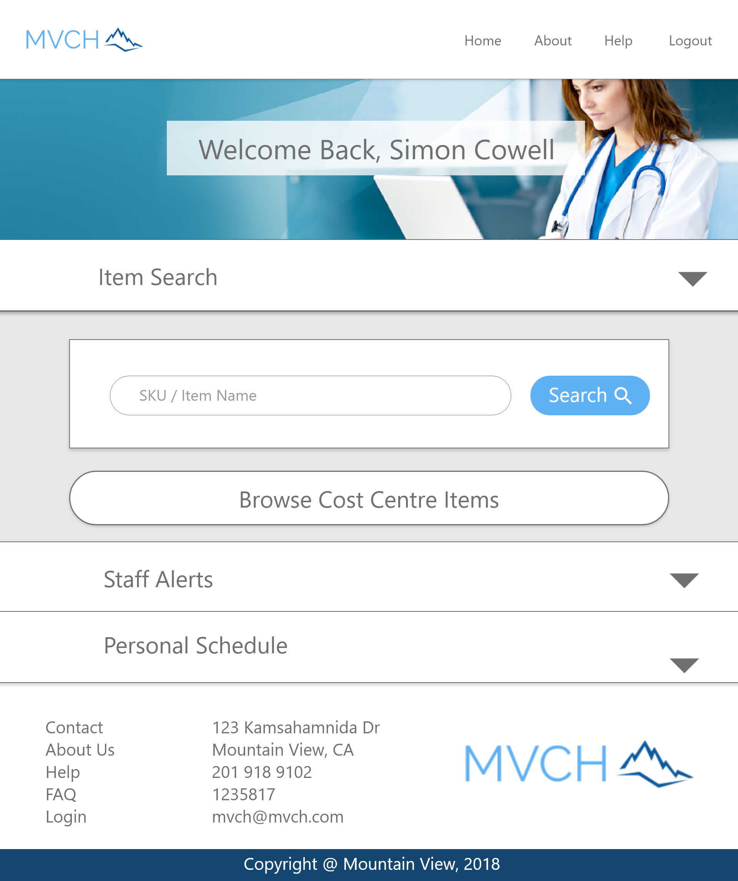

Item Search Entry Area - Enter the name of the item, or part of the name of the item, to search for.

Search Button - Click button after entering item name, or partial item name, to perform the search.

Browse Cost Centre Items Button - Click this button to browse the entire list of cost centre items to add to a patient’s bill.

### 

### Item Information Form

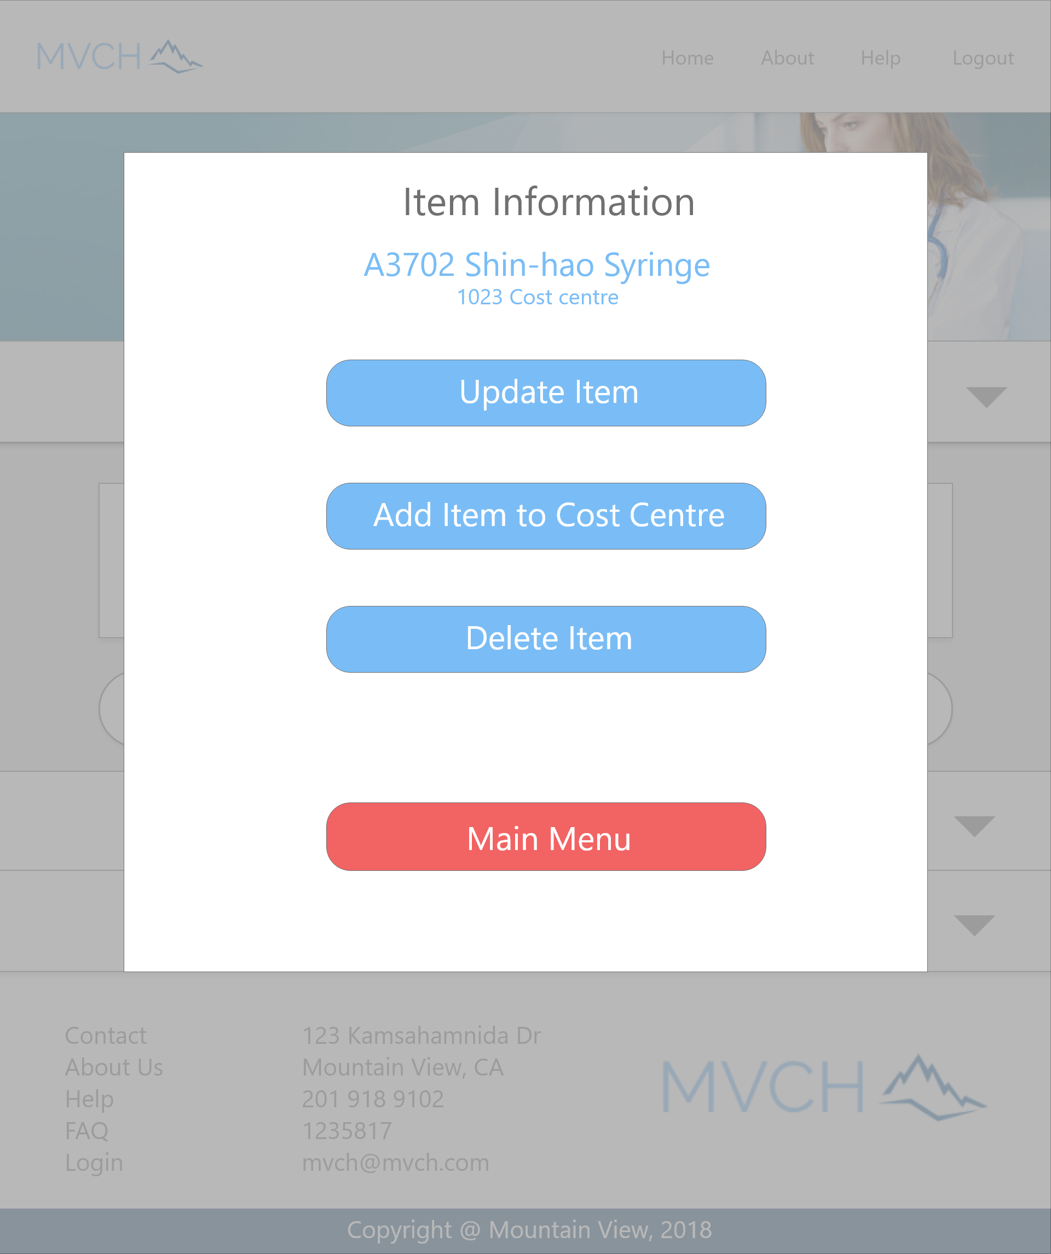

This form displays current information about a selected item based on the item search.

Update Item Button - Click this button to edit this item’s information.

Add Item to Cost Centre Button - Click this button to add an item to the same cost centre as the currently selected item.

Delete Item Button - Click this button to delete the currently selected item from its current cost centre.

Main Menu - Click the Main Menu button to return to the Administrative Staff Login Landing page.

### Add Item to Cost Centre Form

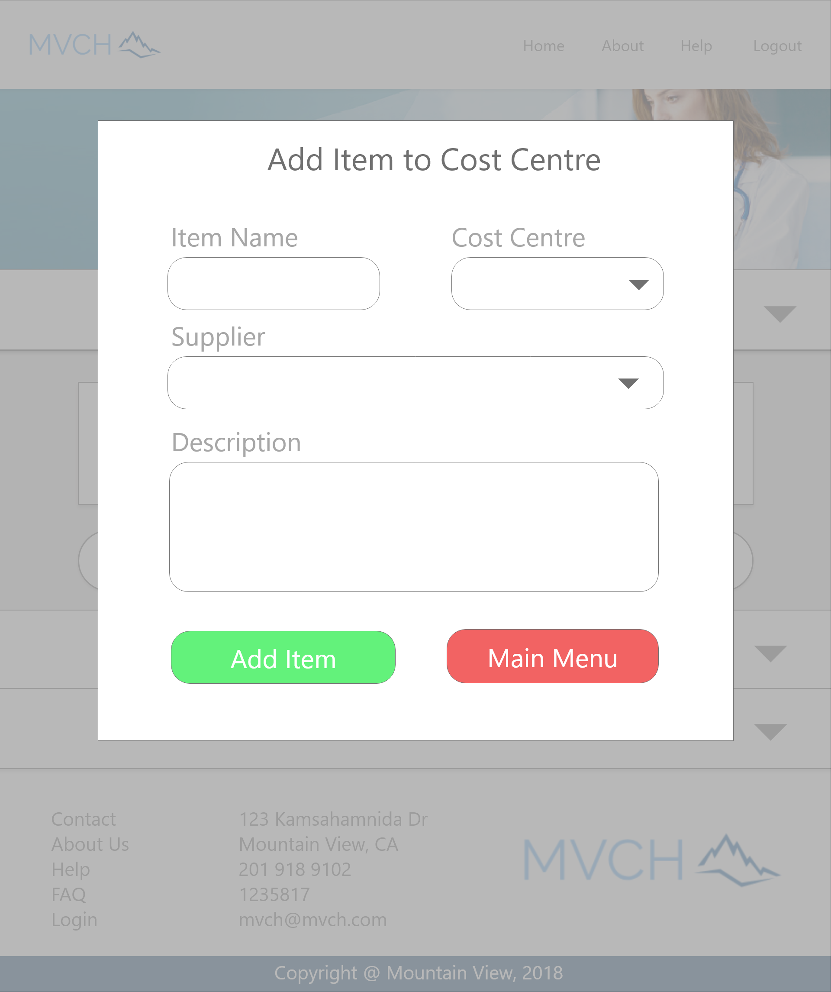

This form is to add a new item to the database.

Item Name Entry Area - Enter the item name you want to add to the database.

Cost Centre Entry Area - Enter the cost centre for the item you are entering. Enter only one.

Supplier Entry Area - Enter the supplier ID by dropdown menu.

Description Entry Area - Enter a brief description of the item if necessary. This can be left blank if no additional description is required.

Add Item Button - Click this button to add the entered item to the database.

Main Menu - Click the Main Menu button to return to the Administrative Staff Login Landing page.

### Cost Centre Item View

This view gives the information about the searched-for item. Will report if no item with a similar name is found.

Main Menu - Click the Main Menu button to return to the Administrative Staff Login Landing page.

## Patient

### Login Landing - Personal Medical Records

Navigation Bar - The navigation bar has navigation links to the Home page, the About page, the Help page, and the Logout function.

Personal Medical Record - Loaded by default is an uncollapsed Personal Medical Records panel.. This pane displays the logged in patient’s recent medical treatments, and can be expanded and collapsed by clicking the grey arrow on the right of the Search Patients panel.

### Login Landing - Current Account

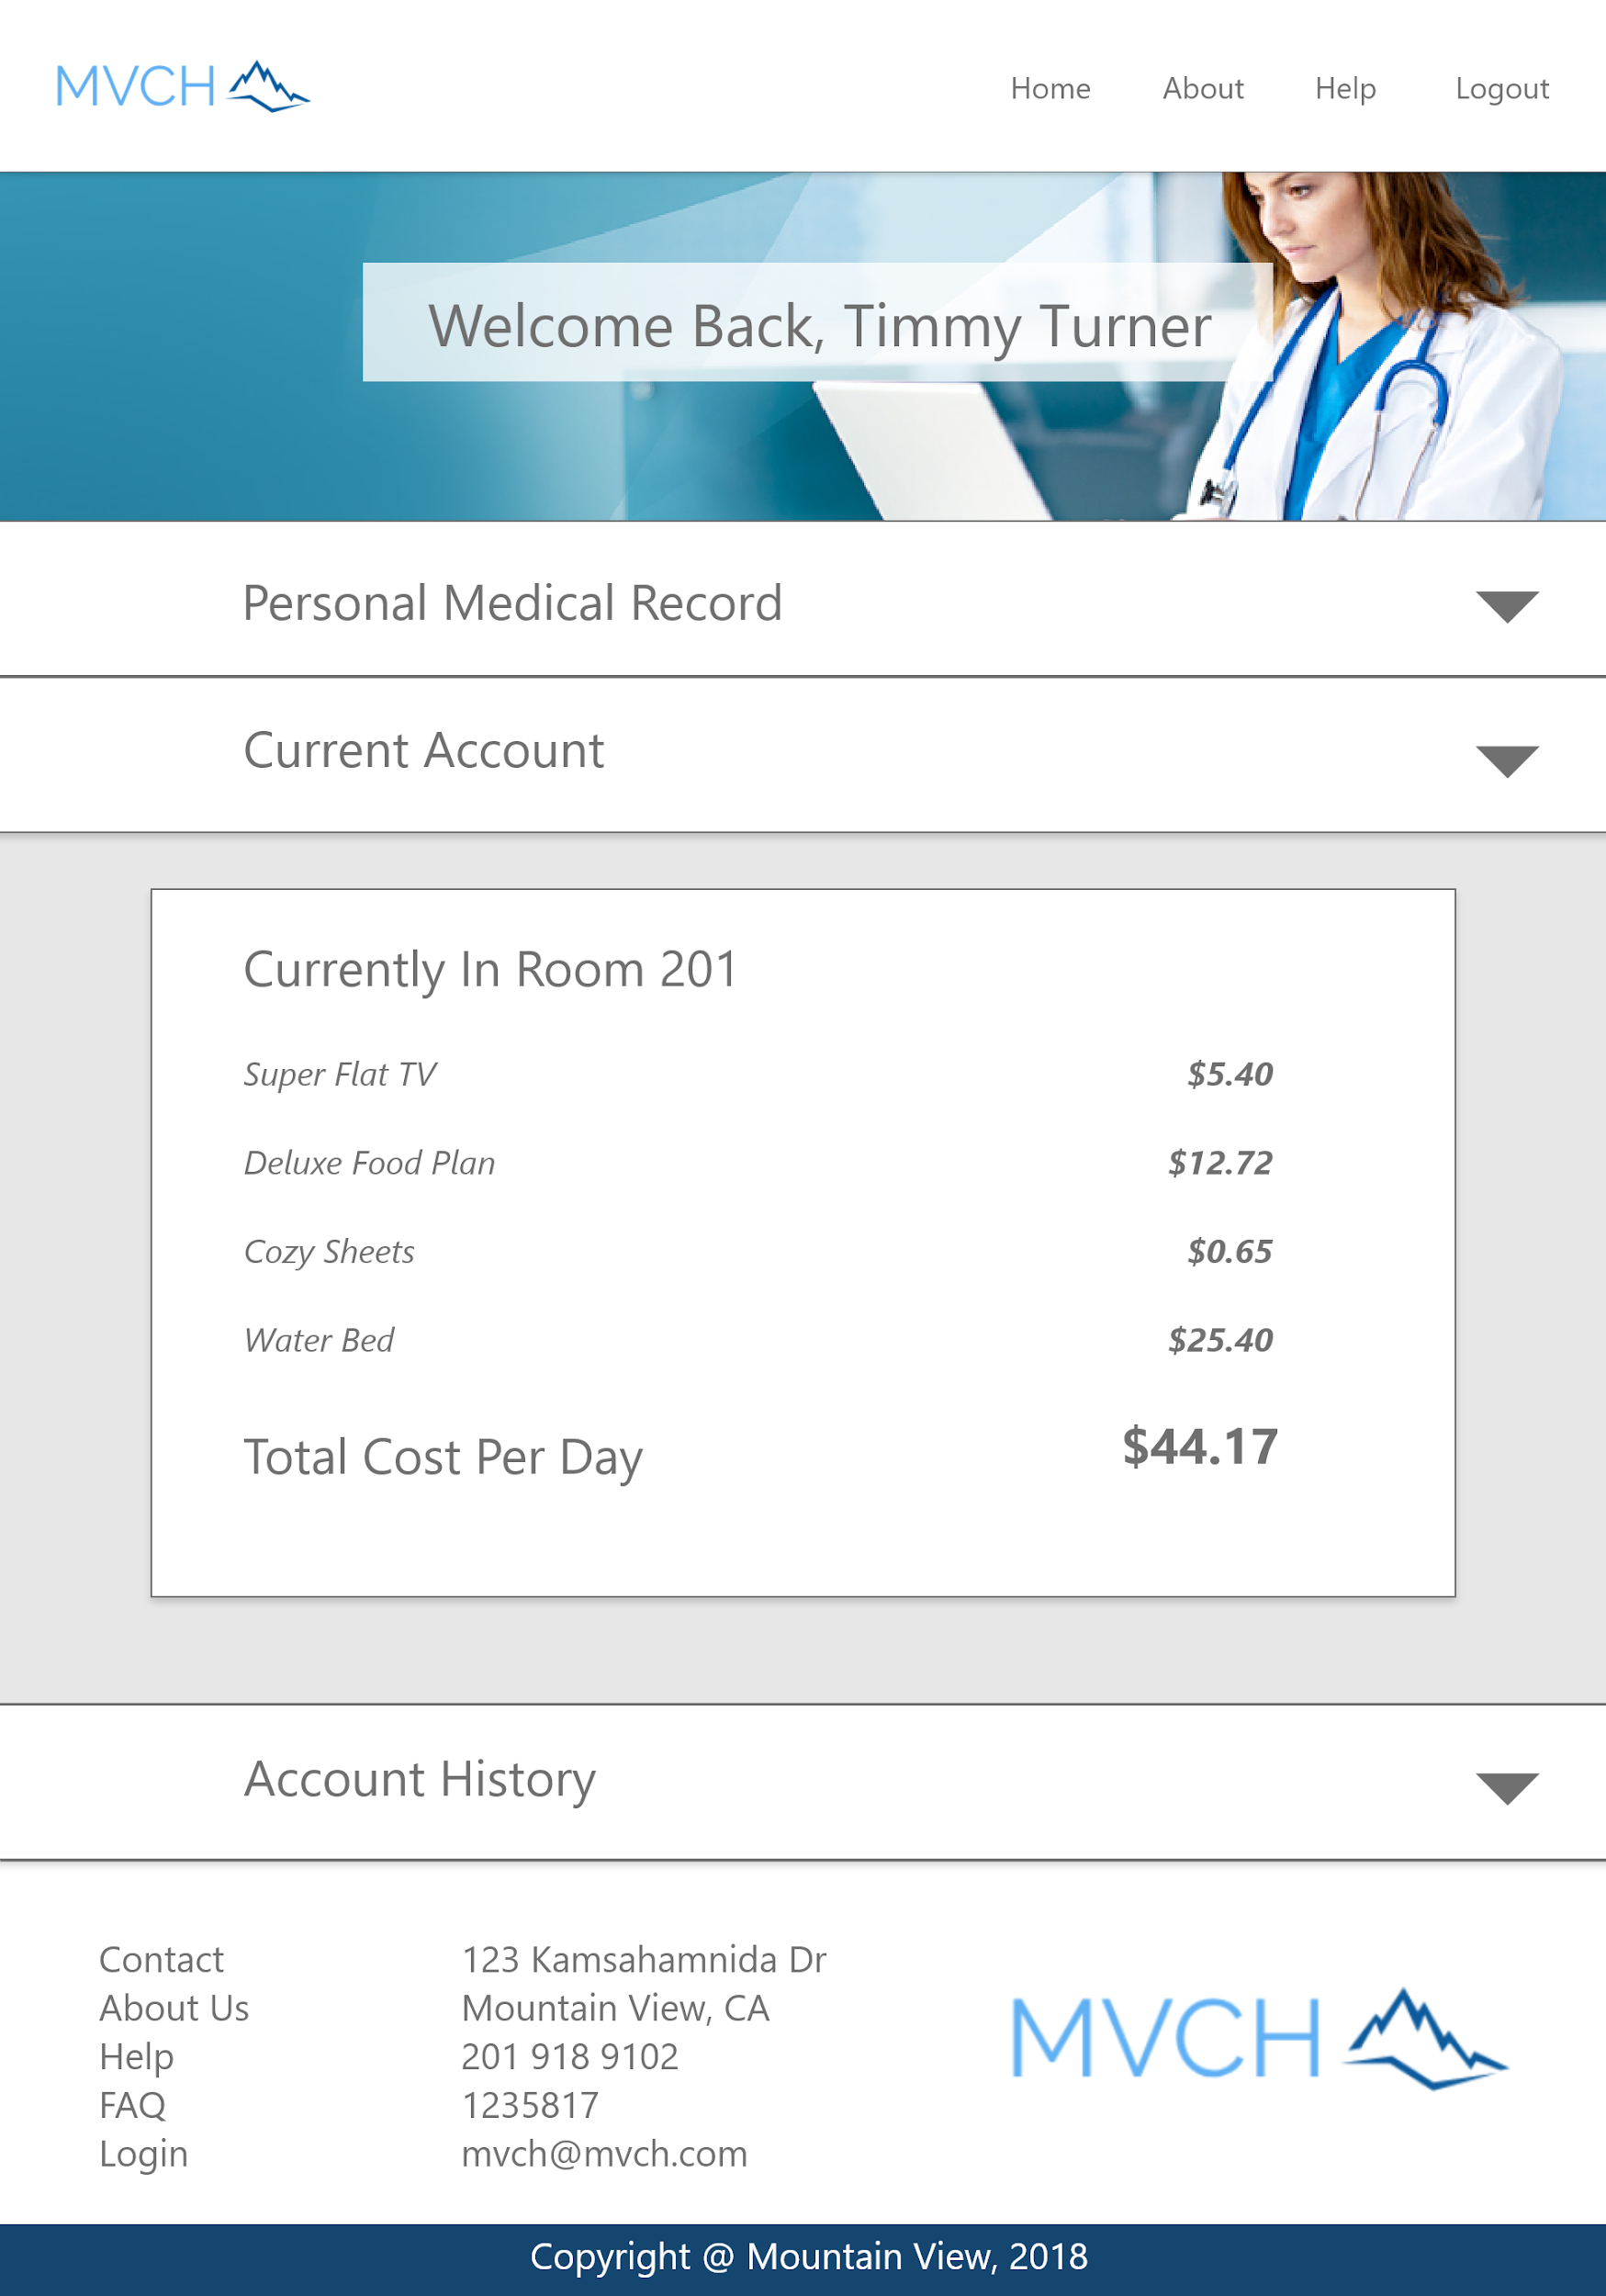

Navigation Bar - The navigation bar has navigation links to the Home page, the About page, the Help page, and the Logout function.

Current Account Panel - Displays an itemized breakdown of the bill for the current patient visit/stay at the hospital.

### 

### 

### 

### Login Landing - Account History

Navigation Bar - The navigation bar has navigation links to the Home page, the About page, the Help page, and the Logout function.

Account History Panel - Displays the totals of past bills from past visits.

# 

# Procedural Documents

## Physician

### How to Login

1. Navigate to the login page by clicking the "Login" button in the navigation bar at the top right of the website.
   1. The login page allows you to login using your credentials.
2. Enter your email into the email field.
3. Enter your password into the password field..
   1. Your password must be at least 6 characters long
   2. Your password may include lowercase or CAPITAL letters, as well as some symbols (!@#$%^&*).
   3. If you have forgotten your password, click on the forgot password link to reset your password.
4. Once you have entered in your email and your password, press the login button.

### How to Logout

1. Click the "Logout" link in the navigation bar at the top right of the website.
   1. This will log you out, and redirect you to the Home page.

### Password Reset

1. On the Password Reset page, enter in the email address associated with your account.
2. Press the Forgot Password button.
   1. A link will be sent to the email address you have entered.
3. Click the link that was sent in an email to your email address.
   1. If you do not see the email or the link, make sure that no-reply@mvch.com has been added as a contact, and that the email is not in your spam folder.
4. You will be brought to a page where you will be able to enter in a new password for your account.
   1. Your password must be at least 6 characters long.
   2. Your password may include lowercase or CAPITAL letters, as well as some symbols (!@#$%^&*).
   3. It is recommended to use a password manager such as [LastPass](https://www.lastpass.com/) or [KeePass](https://keepass.info/) to help you generate a secure password, and to help you remember it.
5. Enter your new password into the password and confirm password fields.
6. Press the Reset Password button.
   1. You will be taken to the login page where you will be able to login with your new credentials

### How to View your Patient List

1. Navigate to the home page by clicking the "Home" button in the navigation bar at the top right of the website.
   1. Loaded by default on the home page is an uncollapsed patient panel.
   2. This panel can be expanded or collapsed by clicking the grey arrow on the right of the Patient List panel.
   3. You can scroll through the patient panel, which displays the name, last visit, phone number, and email of your active patient list.

### How to View your Physician Alerts

1. Navigate to the home page by clicking the "Home" button in the navigation bar at the top right of the website.
   1. Loaded by default on the home page is a collapsed "Staff Alerts" panel.
   2. This panel can be expanded or collapsed by clicking the grey arrow on the right of the "Staff Alerts" panel.
   3. You can scroll through the "Staff Alerts" panel, which displays the contents of each of the alerts.
   4. If there is no "Staff Alerts" panel, there may be no active alerts, or alerts may be deactivated by your Administration.

### How to View your Personal Schedule

1. Navigate to the home page by clicking the "Home" button in the navigation bar at the top right of the website.
   1. Loaded by default on the home page is a collapsed "Personal Schedule" panel.
   2. This panel can be expanded or collapsed by clicking the grey arrow on the right of the "Personal Schedule" panel.
   3. You can view your "Personal Schedule", which displays the contents of your schedule by month and day.

## Administrative Staff

### How to Login

1. Navigate to the login page by clicking the "Login" button in the navigation bar at the top right of the website.
   1. The login page allows you to login using your credentials.
2. Enter your email into the email field.
3. Enter your password into the password field..
   1. Your password must be at least 6 characters long
   2. Your password may include lowercase or CAPITAL letters, as well as some symbols (!@#$%^&*).
   3. If you have forgotten your password, click on the forgot password link to reset your password.
4. Once you have entered in your email and your password, press the login button.

### How to Logout

1. Click the "Logout" link in the navigation bar at the top right of the website.
   1. This will log you out, and redirect you to the Home page.

### Password Reset

1. On the Password Reset page, enter in the email address associated with your account.
2. Press the Forgot Password button.
   1. A link will be sent to the email address you have entered.
3. Click the link that was sent in an email to your email address.
   1. If you do not see the email or the link, make sure that no-reply@mvch.com has been added as a contact, and that the email is not in your spam folder.
4. You will be brought to a page where you will be able to enter in a new password for your account.
   1. Your password must be at least 6 characters long.
   2. Your password may include lowercase or CAPITAL letters, as well as some symbols (!@#$%^&*).
   3. It is recommended to use a password manager such as [LastPass](https://www.lastpass.com/) or [KeePass](https://keepass.info/) to help you generate a secure password, and to help you remember it.
5. Enter your new password into the password and confirm password fields.
6. Press the Reset Password button.
   1. You will be taken to the login page where you will be able to login with your new credentials

## Clerical Staff

### How to Login

1. Navigate to the login page by clicking the "Login" button in the navigation bar at the top right of the website.
   1. The login page allows you to login using your credentials.
2. Enter your email into the email field.
3. Enter your password into the password field..
   1. Your password must be at least 6 characters
   2. Your password may include lowercase or CAPITAL letters, as well as some symbols (!@#$%^&*).
   3. If you have forgotten your password, click on the forgot password link to reset your password.
4. Once you have entered in your email and your password, press the login button.

### How to Logout

1. Click the "Logout" link in the navigation bar at the top right of the website.
   1. This will log you out, and redirect you to the Home page.

### Password Reset

1. On the Password Reset page, enter in the email address associated with your account.
2. Press the Forgot Password button.
   1. A link will be sent to the email address you have entered.
3. Click the link that was sent in an email to your email address.
   1. If you do not see the email or the link, make sure that no-reply@mvch.com has been added as a contact, and that the email is not in your spam folder.
4. You will be brought to a page where you will be able to enter in a new password for your account.
   1. Your password must be at least 6 characters long.
   2. Your password may include lowercase or CAPITAL letters, as well as some symbols (!@#$%^&*).
   3. It is recommended to use a password manager such as [LastPass](https://www.lastpass.com/) or [KeePass](https://keepass.info/) to help you generate a secure password, and to help you remember it.
5. Enter your new password into the password and confirm password fields.
6. Press the Reset Password button.
   1. You will be taken to the login page where you will be able to login with your new credentials

## Patient

### How to Login

1. Navigate to the login page by clicking the "Login" button in the navigation bar at the top right of the website.
   1. The login page allows you to login using your credentials.
2. Enter your email into the email field.
3. Enter your password into the password field..
   1. Your password must be at least 6 characters
   2. Your password may include lowercase or CAPITAL letters, as well as some symbols (!@#$%^&*).
   3. If you have forgotten your password, click on the forgot password link to reset your password.
4. Once you have entered in your email and your password, press the login button.

### How to Logout

1. Click the "Logout" link in the navigation bar at the top right of the website.
   1. This will log you out, and redirect you to the Home page.

### Password Reset

1. On the Password Reset page, enter in the email address associated with your account.
2. Press the Forgot Password button.
   1. A link will be sent to the email address you have entered.
3. Click the link that was sent in an email to your email address.
   1. If you do not see the email or the link, make sure that no-reply@mvch.com has been added as a contact, and that the email is not in your spam folder.
4. You will be brought to a page where you will be able to enter in a new password for your account.
   1. Your password must be at least 6 characters long.
   2. Your password may include lowercase or CAPITAL letters, as well as some symbols (!@#$%^&*).
   3. It is recommended to use a password manager such as [LastPass](https://www.lastpass.com/) or [KeePass](https://keepass.info/) to help you generate a secure password, and to help you remember it.
5. Enter your new password into the password and confirm password fields.
6. Press the Reset Password button.
   1. You will be taken to the login page where you will be able to login with your new credentials

# Tutorials

## All Staff

### How to View Staff Alerts

<https://youtu.be/N92s7cVO1l0>

### How To View Personal Schedule

<https://youtu.be/S--NR0uuULM>

### How To Search Help Topics

<https://youtu.be/lCM9RkbV7XE>

### How To Login

<https://youtu.be/d-YXYNpKBf4>

## Physicians

### How To View Active Patients

<https://youtu.be/YJ1CQFNd1uM>

## Admission Staff

### How To Add A Patient:

<https://youtu.be/kqWYay0FSdY>

### How To Update A Patient

<https://youtu.be/eAVME3h_bW4>

### How To Admit A Patient

<https://youtu.be/kqWYay0FSdY>

### How To Print A Patient Bill

<https://youtu.be/YHkCi6v18do>

## Clerical Staff

### How To Add An Item

<https://youtu.be/cDo4ylM2b2U>

## Patients

### How To View Current Account Balance

<https://youtu.be/yKG2qvph7k0>

# App Walkthrough

For a walkthrough of the app, please visit the following link: https://youtu.be/OWlOPnS3rcc